CASE STUDY
CDAC ADDMISSION PROCESS
INTRODUCTION:
The CDAC Admission Portal is used to manage the admission process for various courses offered by CDAC. Students appear for the CCAT examination and receivea rank based on their performance. Based on the rank, students fill theircourse and center preferences. The system allocates seats according to rank,preferences, and seat availability. This case study designs a database system to manage the admission process using MySQL.

OBJECTIVES:
1. To design a database for CDAC admission system.
2. To store candidate information and CCAT ranks.
3. To manage course and center information.
4. To store candidate preferences.
5. To allocate seats based on rank and preference.

ER DIAGRAM 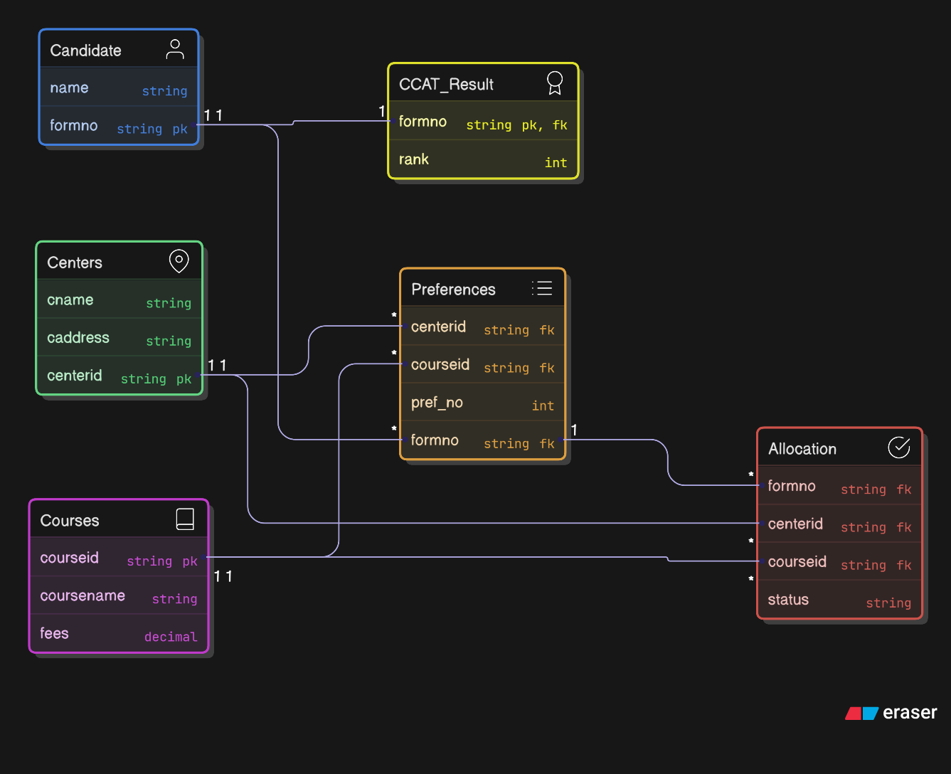
ENTITY DISCRIPTION:
Candidate
Stores candidate details.
Attributes
- formno (Primary Key)
- name

CCAT_Result
Stores candidate rank.
Attributes
- formno (Primary Key, Foreign Key)
- rank
Centers
Stores CDAC center information.
Attributes
- centerid (Primary Key)
- cname
- caddress
Courses
Stores course details.
Attributes
- courseid (Primary Key)
- coursename
- fees
Preferences
Stores student course-center preferences.
Attributes
- formno
- centerid
- courseid
- pref_no

Allocation
Stores seat allocation results.
Attributes
- formno
- centerid
- courseid
- status

DATABASE TABLES (MySQL)
CANDIDATE TABLE
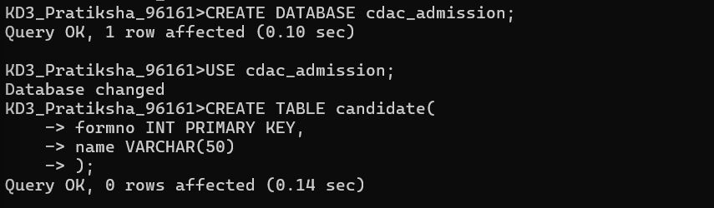

CCAT RESULT TABLE
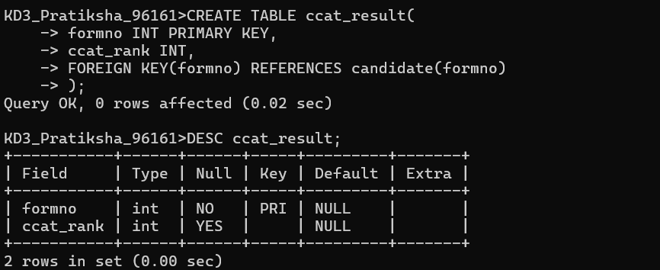

CENTERS TABLE
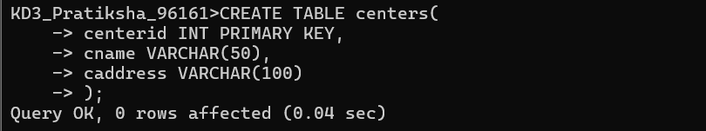

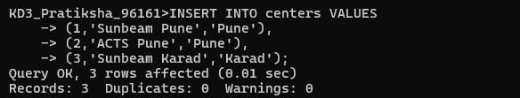
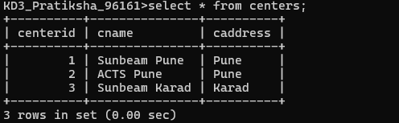

COURSES TABLE
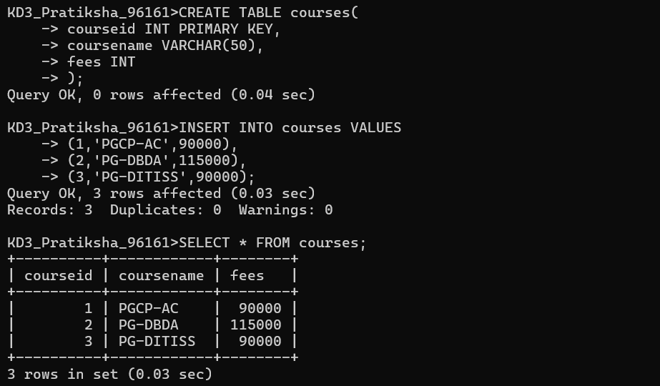

CENTRE COURSE TABLE
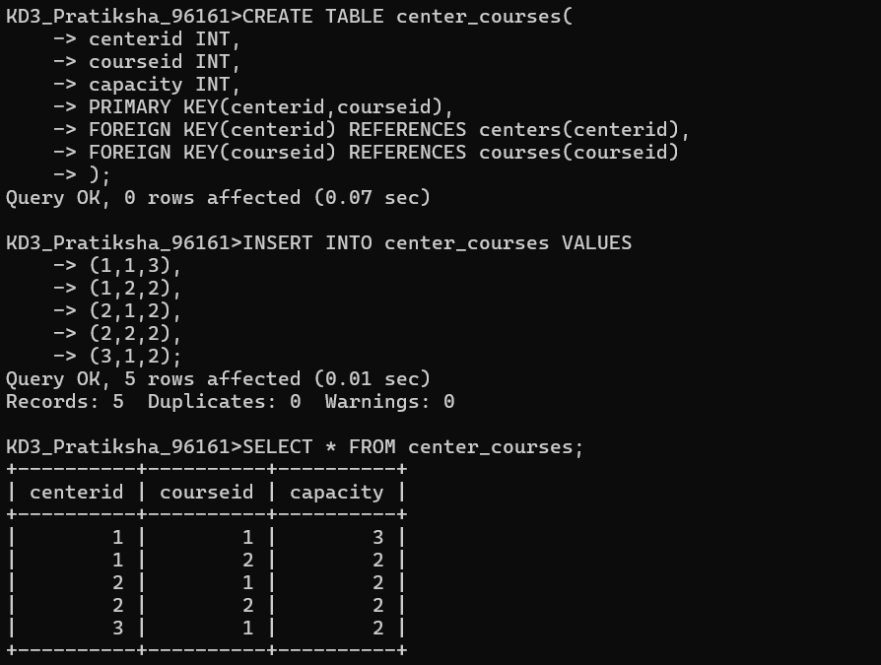

PREFERANCE TABLE
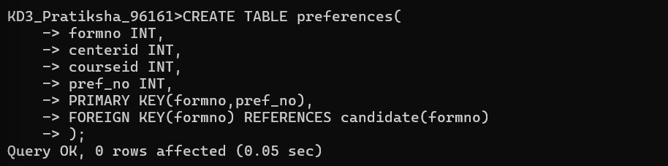

ALLOCATION TABLE
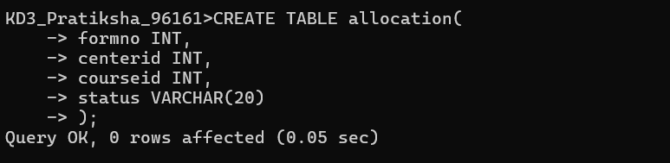

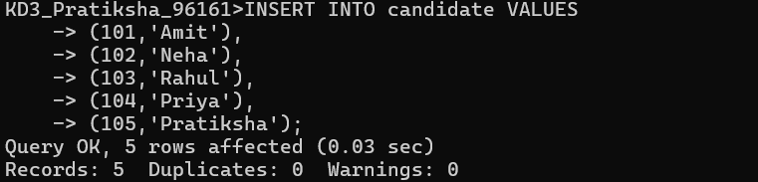
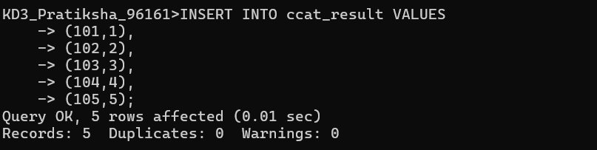
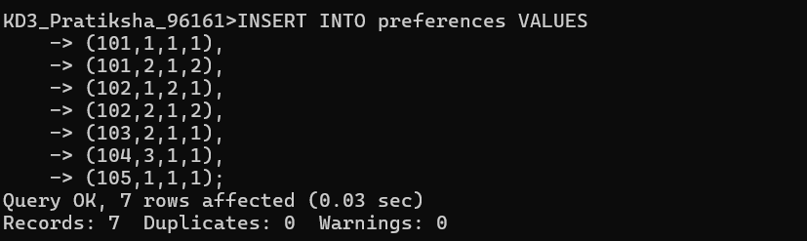

STORED PROCEDURE (Round 1 Allocation)
This procedure allocates seats based on rank order
Seat Allocation Logic
The system allocates seats using the following logic:
- Candidates are sorted based on CCAT rank.
- The system checks the candidate's first preference.
- If a seat is available, the seat is allocated.
- If the seat is not available, the system checks the next preference.
- The allocated seat is stored in the Allocation table.
.
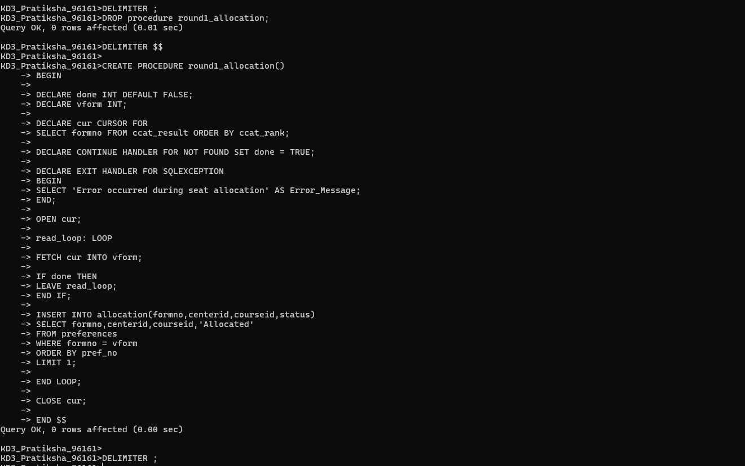

Freeze Option
After seat allocation, candidates can choose the Freeze option.
Freeze means the candidate accepts the allocated seat and will not participate in further admission rounds.

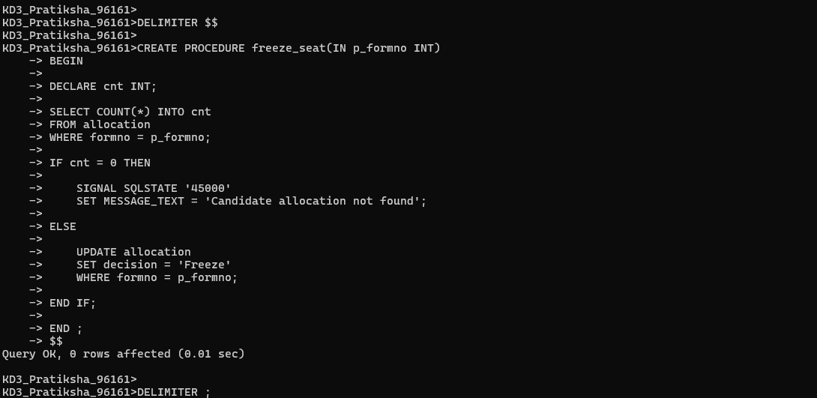

FINAL OUTPUT
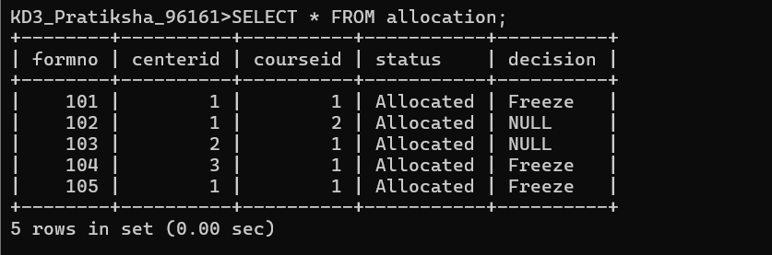

CONCLUSION
The CDAC Admission Portal database system efficiently manages the entire admission process. It stores candidate information, exam results, course and center details, preferences, and seat allocation results. The system ensures fair seat allocation based on rank and candidate preferences.

